Elastic Load Balancing (ELB)
Purpose of ELB
- Elastic Load Balancing (ELB) distributes incoming traffic across multiple EC2 instances.
- It ensures high availability, fault tolerance, and better performance.
- Requests from users (clients) go through the load balancer, which routes them to one of the backend EC2 instances.
- Return traffic also flows back through the load balancer to the client.

High Availability and Scalability
- ELB appears as a single component but is not a single point of failure.
- It is a regional service, managed and maintained by AWS for high availability.
- ELB automatically scales to handle varying traffic loads—no manual scaling required.

Types of Load Balancers
- Application Load Balancer (ALB) – Handles HTTP and HTTPS traffic (Layer 7).
- Network Load Balancer (NLB) – Handles TCP, UDP, and TLS traffic (Layer 4).
- Gateway Load Balancer (GLB) – Used for third-party applications such as firewalls or monitoring tools.
- For the Employee Directory App, the ALB is used since it handles web (HTTP) traffic.

Main Components of an ALB
- Listener
  - Listens for incoming requests on a specific port and protocol.
  - Example: Port 80 (HTTP) or 443 (HTTPS).
- Target Group
  - A group of backend resources (e.g., EC2 instances, Lambda functions, or IP addresses).
  - Includes health checks to determine if a target is healthy and ready to receive traffic.
- Rules
  - Define how traffic is routed to target groups.
  - Example: Traffic to /info could go to a different target group (e.g., target group B).
  - Rules allow path-based routing, possible because ALB operates at Layer 7 (application layer).

Creating an ALB in AWS Console
- Go to the EC2 console → Load Balancers section.
- Click Create Load Balancer and choose Application Load Balancer.
- Name it (e.g., app-elb).
- Choose Internet-facing (for public access).
  - Internal-facing is used for private communication (e.g., between app and database tiers).
- Select the VPC and Availability Zones with public subnets.
- Assign a security group that allows traffic on port 80 (HTTP).
- Configure listeners (default: HTTP on port 80).
- Create a target group (e.g., app-target-group) → choose instances as target type.
- Add the EC2 instances (from private subnets) to the target group.
- Return to load balancer setup → select the created target group → click Create Load Balancer.

Testing the ALB
- After creation, select the ALB and find its DNS URL in the description.
- Open the DNS URL in a browser → application should load.
- Visiting /info shows which Availability Zone (AZ) you’re connected to.
- Refreshing the page shows traffic being distributed between the two EC2 instances.

Key Takeaways
- ELB improves fault tolerance and scalability automatically.
- ALB offers Layer 7 routing and supports HTTP/HTTPS traffic.
- Health checks ensure traffic only goes to healthy instances.
- Listeners, target groups, and rules define how incoming requests are handled.
- Using internet-facing ALB allows public web access, while internal-facing ALB supports private internal routing.
Load balancers
- Load balancing is the process of distributing incoming tasks or requests across multiple resources.
- In the Employee Directory application, the resources are EC2 instances, and the tasks are client requests.
- A load balancer evenly distributes incoming traffic among the servers hosting the application.
- It redirects traffic to backend servers using an algorithm — the most common one is round robin, which sends requests to each server in sequence.
- The typical flow:
  - Client’s browser → Load Balancer → EC2 instance → Load Balancer → Client’s browser.
- While you can manually set up your own software load balancer on EC2, AWS provides Elastic Load Balancing (ELB) as a managed, scalable, and fault-tolerant service.
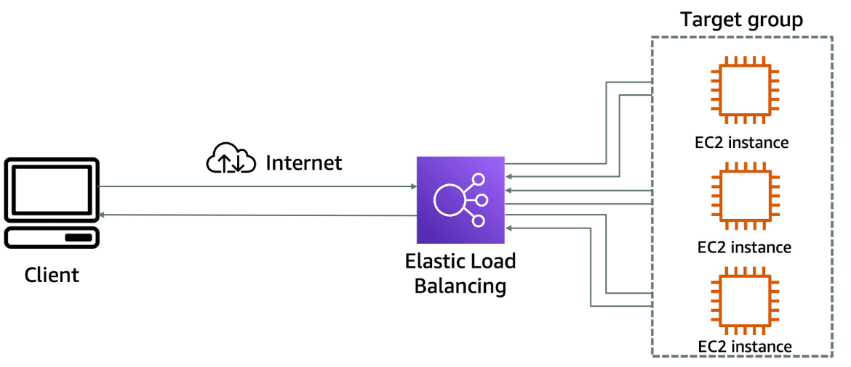
ELB features
- Elastic Load Balancing (ELB) offers a major advantage — it’s fully managed, so you don’t need to maintain or operate it yourself.
- ELB can distribute traffic across multiple target types, including EC2 instances, containers, IP addresses, and Lambda functions.
- Key features of ELB:
- Hybrid mode: Can route traffic to on-premises servers as well as AWS resources using IP-based targets.
- High availability: Automatically provides fault tolerance; you only need to deploy targets across multiple Availability Zones.
- Scalability: Automatically scales to handle changes in incoming traffic without manual configuration.
- Overall, ELB simplifies traffic distribution, improves reliability, and adapts automatically to workload demands.
Health Check
Importance of Monitoring
- Monitoring ensures the load balancer routes traffic only to healthy EC2 instances.
- Elastic Load Balancing (ELB) supports two main types of health checks.

Types of Health Checks
- TCP health check:
  - Establishes a TCP connection with the backend instance.
  - If successful, the instance is marked as healthy.
- HTTP/HTTPS health check:
  - Sends a web request to a specified URL or page.
  - Marks the instance as healthy if a valid HTTP response code is returned.

Defining Effective Health Checks
- Proper health checks are critical — checking only if a port is open doesn’t guarantee the application is fully functional.
- Example: For the Employee Directory application, which depends on a database and Amazon S3, the health check should verify both dependencies.
- A good approach is to create a custom monitoring endpoint, such as /monitor, that:
  - Tests database connectivity.
  - Retrieves data.
  - Verifies S3 access.
- The ELB health check should then point to this /monitor page.

Instance Health and Traffic Management
- When a new EC2 instance passes the health check, ELB starts routing traffic to it.
- If an instance fails the health check, ELB stops sending traffic and notifies Amazon EC2 Auto Scaling.
- Auto Scaling then removes the unhealthy instance and replaces it with a new one.
- Traffic is only sent to the new instance after it passes its health check.

Connection Draining
- When Auto Scaling needs to scale down, it informs ELB that an instance will be terminated.
- Connection draining ensures:
  - Existing connections to that instance finish before termination.
  - No new connections are routed to it.

Summary
- ELB health checks are essential for application reliability and stability.
- They integrate with EC2 Auto Scaling to maintain a healthy, elastic environment.
- Connection draining ensures smooth scaling and prevents user disruptions.
ELB components
three main components of the ELB (Elastic Load Balancing) service:
1. Listeners
- A listener is the entry point for the load balancer.
- It checks for connection requests from clients using the protocol (HTTP, HTTPS, TCP, etc.) and port you configure.
- When a listener receives a request, it applies the rules to determine where to send the traffic.
- Example:
  - Listener protocol: HTTP
  - Port: 80
  - Action: Forward requests to a target group.

2. Rules
- Rules define how requests are routed from the listener to the target groups.
- Each rule consists of:
  - Conditions (e.g., URL path /images, host header app.example.com)
  - Actions (e.g., forward to a specific target group).
- The default rule is used when no other rules match.
- Example:
  - Rule condition: If the path is /api/*,
  - Action: Send traffic to the API target group.

3. Target Groups
- A target group is a set of resources (targets) — such as EC2 instances, containers, IP addresses, or Lambda functions — that the load balancer sends traffic to.
- ELB uses health checks to monitor each target within the group.
- Only healthy targets receive traffic.
- You can have multiple target groups, each serving a different part of your application.
- Example:
  - Target group 1 → EC2 instances running the frontend
  - Target group 2 → EC2 instances running the backend
Client Request
↓
Listener (Port 80)
↓
Rule: If path = /api/*
↓
Target Group (Healthy EC2 instances)
↓
Health Check → Verifies availability
✅ In short:
- Listener – receives the request.
- Rule – decides how to route it.
- Target group – sends it to healthy backend instances.
Type of Load Balancers
Three types of load balancers:
- Application LB
- Works at the Application Layer (Layer 7) of the OSI model.
- Best suited for HTTP and HTTPS traffic.
- Can inspect the content of the request (like URL path or host) to make routing decisions.
- Supports advanced routing features such as:
  - Path-based routing (/images, /api, etc.)
  - Host-based routing (api.example.com, app.example.com)
  - Redirects and fixed responses
- Commonly used for web applications, microservices, and containerized workloads.

- Network LB
- Operates at the Transport Layer (Layer 4).
- Designed for ultra-high performance and low latency.
- Can handle millions of requests per second while maintaining high throughput.
- Routes traffic based on IP protocol data (like TCP, UDP, or TLS).
- Best for applications that require:
- Extreme performance
- Static IP addresses
- Preservation of client IPs
- Commonly used for gaming, IoT, VoIP, or real-time communications.

- Gateway LB
- Operates at the Network Layer (Layer 3).
- Designed to deploy, scale, and manage third-party virtual appliances, such as:
- Firewalls
- Intrusion Detection/Prevention Systems (IDS/IPS)
- Deep Packet Inspection tools
- Acts as a transparent gateway—it intercepts traffic and sends it through your virtual appliances before routing it back.
- Provides load balancing + gateway functionality in one service.
Resources
(opens in a new tab)For more information, see the following resources:
- AWS website: Elastic Load Balancing features(opens in a new tab)
- AWS website: AWS Certificate Manager(opens in a new tab)
- AWS documentation: Authenticate users using an Application Load Balancer(opens in a new tab)
- AWS developer guide: How AWS WAF works(opens in a new tab)
- AWS blog: Introducing AWS Gateway Load Balancer(opens in a new tab)

